**Local Area Assessment**

77 Donnybrook Road, Streatham, London SW16 5AY

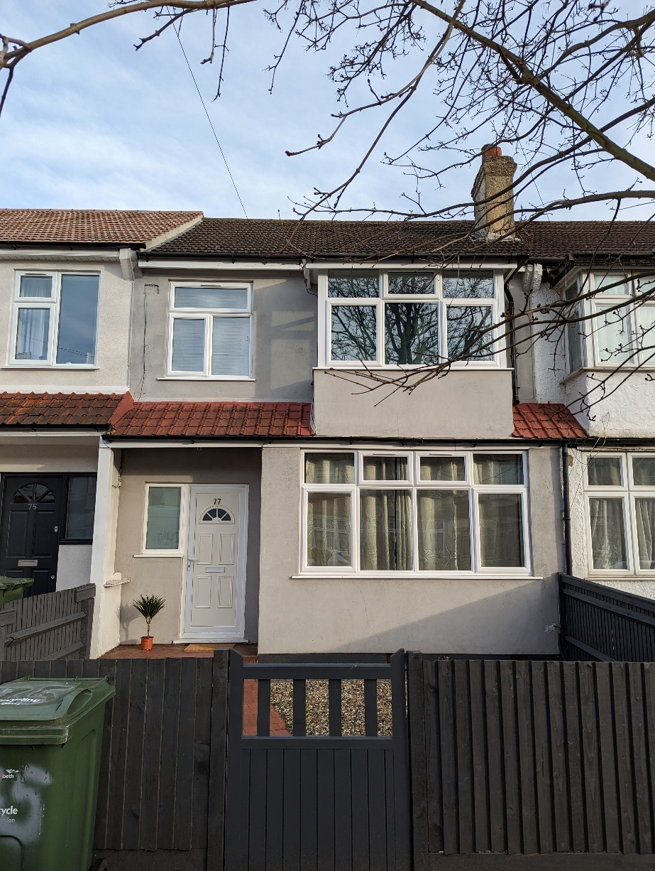

1. Local Area Resources
2. Local Risk Assessment
3. **Local Area resources**

**Accessibility of Local Resources**

Donnybrook Road is in the London region of England. The postcode is within the Streatham Common & Vale ward/electoral division, which is in the constituency of Streatham.Donnybrook road is a street located in London, with a postcode of SW16 5AY. There have been 42 property transactions in this postcode since 1995, with 22 unique properties. The most common property type in this street is terrace. The most recent sale was on Friday, 16 December 2022 at 37 Donnybrook road which sold for £695000. The average broadband download speed is 184.80 mbps. There are 10 nearby train stations, 1 nearby bus stops and 12 nearby schools. SW16 5AY postcode was first in introduced in January 1980. SW16 5AY is located within the London Travel To Work Area. NHS Services in this postcode are provided by the Lambeth Primary Care Trust. The 2011 Census Output Area for this postcode is classified as 'Multicultural metropolitans, Challenged Asian terraces, Asian terraces and flats'. SW16 5AY has an Index of Multiple Deprivation of 20521

**Socio Demographics**

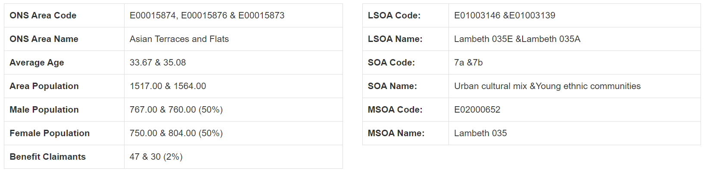

Donnybrook Road, London can be considered more ethnically diverse than the UK average. As whole, the UK population claims itself as approximately 86% white, with residents of this area being 40% so.

As a country with a diverse population, the UK is home to other sizable ethnic groups, with mixed ethnicity (2.1%), Indian (2.4%) and Pakistani (1.9%) being the largest groups reported.

There is considerable division of ethnicities within the UK, with ethnically diverse addresses uncommon outside of urban areas.

Social Grade approximations are derived from an algorithm created by the Market Research Society. The figures shown are per-household rather than individual - more specifically, the job title and employer of the "household reference person" is used, analogous to what traditionally was called the head of the household. Only household reference persons between the ages of 16-64 are included.

Across the UK as a whole, the gender split is roughly equal at 49% male, 51% female. This address in Streatham constituency is broadly in line with those figures, with 48% male.

Across the UK as a whole, the median age is 39. In general, inner city areas show high concentrations of people aged 18-30, suburbs show larger numbers of small children and adults aged 30-50, and rural and small towns are more popular with older workers and retirees. Many poorer areas lack a majority age group, which is due in part to the people in that area being constrained by circumstance rather than being able to choose where to retire, raise a family or grow up.

The postcode SW16 5AZ does not show a significant deviation from the average figures for the UK. In the UK as a whole, the average figures are approximately as follows for relationship statuses: 34% single, 47% married, 3% separated, 9% divorced, 7% widowed, and 0.2% same sex.

Health in the UK is strongly tied to age as you would expect, but the affluence of a neighbourhood also has strong influence, with deprived areas often showing poorer standards of health.

Overall, the UK considers itself to be healthy - 81.1% of residents rated their health as Very Good or Good. The full breakdown is as follows for the United Kingdom: 47.1% Very Good, 34% Good, 13.3% Fair, 4.3% Bad and 1.3% Very Bad.

At the time of the 2011 census, across the UK 22.9% of residents had no qualification, 13.2% had 1-4 GCSEs, 15.2% had 5+ GCSEs and 1-2 A/AS-Levels, 12.3% had 2+ A-Levels, 27.1% had a degree (or similar), and 3.6% had an apprenticeship.

The qualification levels are based on current qualification names. The former Ordinary Levels (O-Levels) and CSEs will be included in the GCSE figures. Former Higher School Certificates (HSCs) will be counted as A Levels.

England and Wales are primarily Christian countries, with 59.3% of residents Christian. However, a sizeable portion of the population (25.1%) claim to have no religion. Some 4.8% identify themselves as Muslim, 1.5% Hindu, 0.4% Buddhist, 0.5% Jewish, 0.8% Sikh, and 0.4% as other religions, while the remaining 7.2% did not state their religious views.

**Local Resource Assessment**

**Education Resources and Performance**

## Bonus Pastor Catholic College

## **1.1** **miles**

## <http://www.bonuspastor.co.uk/>

## Haberdashers' Knights Academy

## **1.1** **miles**<https://www.habsknights.org.uk/>

## Conisborough College

**0.8 miles**

<http://www.conisboroughcollege.co.uk/>

**Transport**

### **Rail/Underground/Ferry Stations**

* Streatham Common Rail Station   -   0.2 m
* Streatham Rail Station   -   0.7 m
* Mitcham Eastfields Rail Station   -   0.9 m
* Norbury Rail Station   -   0.9 m
* Tooting Rail Station   -   0.9 m

### **Bus Stops**

* Braeside Road - Stop VK   -   0.1 m
* Braeside Road - Stop VJ   -   0.1 m
* Streatham Common Station - Stop CR   -   0.1 m
* Streatham Common Station - Stop CS   -   0.2 m
* Streatham Common Rail Station - Entrance 2   -   0.2 m
* Streatham Common Rail Station   -   0.2 m
* Streatham Common Rail Station - Entrance 1   -   0.2 m
* Tankerville Road - Stop CT   -   0.3 m
* Streatham Common - Stop CQ   -   0.3 m
* Greyhound Terrace - Stop VH   -   0.3 m

**Shopping Facilities:**

## Supermarkets

* Cost Cutter 0.3 miles
* Co-Operative Food 0.6 miles
* Co-op 0.7 miles
* Co-op Late Store 0.8 miles
* Sainsbury's 0.9 miles
* Co-op Food 1.0 miles
* Nisa 1.1 miles
* Aldi Stores Limited 1.1 miles
* Tesco's 1.1 miles
* J Sainsbury plc 1.1 miles

## Grocery stores

* JB Express 162 yards
* Lloyds Pharmacy Ltd 0.2 miles
* Shell Service Station 0.2 miles
* Shell Service Station 0.2 miles
* Best way Cash and Carry 0.3 miles
* TVS Retail Ltd (Londis) 0.3 miles
* Mace Convenience Store 0.3 miles
* Torridon Convenience Store 0.3 miles
* Pizza Roma 0.4 miles
* Newsagents 0.5 miles

**Health Services**

### **GPs (General Practitioners)**

* The Vale Surgery   -   0.1 m
* The Greyswood Practice   -   0.3 m
* The Practice Furzedown   -   0.4 m
* The Rowans Surgery   -   0.4 m
* Streatham Common Group Practice   -   0.5 m

### **Dentists**

* Streatham Vale Dental Practice   -   0 m
* Streatham Common Dental Surgery   -   0.2 m
* D'Souza, Karl Francis   -   0.5 m
* One One Nine Family Dental Care   -   0.6 m
* Streatham Dental Centre   -   0.6 m

### **Hospitals**

* Wilson Hospital   -   1.7 m
* St George's Hospital   -   1.7 m
* Springfield University Hospital   -   2.1 m
* Croydon University Hospital   -   2.3 m
* West Valley Hospital   -   3 m

### **Pharmacies**

* Watts Pharmacy   -   0.1 m
* Fairlight Chemist   -   0.4 m
* Fairoak Pharmacy   -   0.4 m
* LloydsPharmacy Inside Sainsbury's   -   0.5 m
* Copes Pharmacy   -   0.6 m

### **Opticians**

* Visionary Eyecare Limited   -   0.5 m
* Tesco Opticians Streatham   -   0.7 m
* J S Robin   -   0.8 m
* London Eye Care Centre   -   0.9 m
* Optics Vision   -   1 m

### **Clinics**

* Gstt @ Woodmansterne Children's Centre   -   0.3 m
* Trevelyan Road Medical Practice   -   0.3 m
* The Practice Furzedown   -   0.4 m
* Dove House   -   0.5 m
* Gstt @ Baldry Gardens   -   0.6 m

### **Other Nearby Services**

* Daffodils Day Nursery   -   0.1 m
* Sing And Sign Classes Streatham Vale   -   0.2 m
* Granton Primary School   -   0.2 m
* Tiny Tots Nursery@ Eardley   -   0.2 m
* Sensory Land   -   0.3 m
* Redfern Psychology Services (Rps) Ltd   -   0.3 m
* Little Linguists Nursery School   -   0.3 m
* Kiddies Kottage Nursery   -   0.3 m
* Rocking Robin   -   0.4 m
* Stockport Road Playing Fields   -   0.4 m

### **Secondary Schools**

* Woodmansterne School   -   0.3 m
* Graveney School   -   0.7 m
* St Mark's Church of England Academy   -   1 m
* Harris Academy Merton   -   1 m
* Bishop Thomas Grant Catholic Secondary School   -   1.1 m

**Places of Worship**

### **Mosques**

* Hyderi Islamic Centre   -   0.3 m
* Shia Islamic Education Society   -   0.3 m
* Al Madina Islamic Centre   -   0.6 m
* Norbury Islamic Academy   -   0.7 m
* Al Noor Institute   -   0.8 m

### **Churches**

* Holy Redeemer - Streatham   -   0.2 m
* St James' Church - Streatham   -   0.4 m
* Mitcham Lane Baptist Church   -   0.5 m
* Streatham Baptist Church   -   0.5 m
* Norbury Baptist Church   -   0.9 m

### **Gurdwaras**

* Siri Guru Singh Sabha   -   1.1 m
* Khalsa Centre   -   1.6 m
* Nanak Community Centre   -   3 m
* South London Sikh Gurdwara   -   3.5 m
* Gurdwara Baba Bhudha Sahib Ji   -   4 m

### **Synagogues**

* South London Synagogue   -   1.5 m
* The Wimbledon Synagogue   -   4 m
* Sutton & District Synagogue   -   4.5 m
* Chelsea (Affiliate) Synagogue   -   5 m
* Catford & Bromley (Affiliate) Synagogue   -   5.3 m

### **Mandirs/Temples**

* Int. Swaminarayana Satsang Organisation, Streatham   -   0.6 m
* Muththumari Amman Temple, Tooting   -   1.5 m
* Shakti Ganapathy temple   -   2.1 m
* Radha Krishna Temple, Balham   -   2.2 m
* Ganapathy Temple, Wimbledon   -   2.2 m

**Council Facilities**

Lambeth Council

1.3(64) · Council

10 Wandsworth Rd · In St George Wharf · +44 345 302 2312

Lambeth Civic Centre

2.6(63) · Local government office

Civic Centre, 6 Brixton Hill · +44 20 7926 1000

1. **Local Risk Assessment**

**Crime**

**Crime Breakdown**

[Donnybrook Road, London, SW16 5AY](https://www.streetcheck.co.uk/postcode/sw165ay) is within the [**Streatham Common and Vale**](https://www.streetcheck.co.uk/policing/metropolitan/e05014112-streatham-common-and-vale) policing neighbourhood, under the [**Metropolitan Police Service**](https://www.streetcheck.co.uk/policing/metropolitan) force area.

We have found **124** crimes in February 2023 within half a mile of the centre of [SW16 5AY](https://www.streetcheck.co.uk/postcode/sw165ay).

Low crime rates **3/10**

Most common crime types

* Anti-social behaviour
* Violence and sexual offences
* Vehicle crime

**Missing Person and CSE Support**

To prevent, pursue and divert or to prosecute and support victims.

Concerns to be reported by calling 101 (999 in an emergency)

If you don't believe the risk requires immediate action, contact the Multi Agency Safeguarding Hub (MASH) and Child Protection team to discuss your concerns: Tel: 0300 126 7000.

<https://www.nctrust.co.uk/help-and-protection-for-children/protecting-children-information-for-professionals/Pages/contact-early-help-support-MASH.aspx>

**CSE Awareness Campaign**

A county-wide campaign to raise awareness of Child Sexual Exploitation (CSE) continues to run in London.

The campaign helps people across the county recognise the signs of CSE with a wide range of resources available from all partner organisations in county.

In addition, the campaign directly targets young people. Some children do not see themselves as victims of CSE, and the campaign aims to speak directly to those who might themselves be victims or who might see the signs in someone in their peer group.

On 24th March 2017, the Office of the Police and Crime Commissioner held a conference launching a 10-point pledge around child abuse. CSE was a key focus to this event which was well attended by a wide variety of practitioners across the county.

Where there are also concerns about Child Sexual Exploitation (CSE) with a child, and their case has been heard at MASE (Multi-agency sexual exploitation panel), the minutes and actions from the MASE will be shared with the missing group. The decision about whether a child needs to be discussed at the missing children operational group as well as MASE will be made on a case by case basis. It will sometimes be necessary to hold a CSE strategy meeting for a child referred into the panel where there are links to CSE, and it is expected that this will take place prior to the referral being made to the panel.

**Nearest Police Stations**

Stockwell station

256 Clapham Rd, London SW9 9AE, United Kingdom

[+44 20 7918 8690](https://www.google.com/search?q=donnybrook+road+london+sw16+5az+nearest+police+station&ei=ngdWZJLZL_Hi7_UP5I6lwA0&ved=0ahUKEwiSoJqum-D-AhVx8bsIHWRHCdgQ4dUDCA8&uact=5&oq=donnybrook+road+london+sw16+5az+nearest+police+station&gs_lcp=Cgxnd3Mtd2l6LXNlcnAQAzoICAAQogQQsAM6BQgAEKIEOgQIIRAKSgQIQRgBUL0EWIITYIQWaAFwAHgAgAHWAogBjRCSAQUyLTcuMZgBAKABAcgBBcABAQ&sclient=gws-wiz-serp)

**Lambeth General Reputation**

Lambeth stretches all the way from the buzzing, touristy Southbank to the calm greenery of Clapham Common, with a myriad of different urban centres and communities in between”

As well as being the 4th most densely populated area in Britain, this is also one of the most vibrant boroughs in the capital, with a culturally diverse population and an eclectic selection of landmarks ranging from the feast of sights and smells at Brixton Market to the iconic red O-X-O of the OXO Tower. It is famous for offering locals a vibrant mix of vintage markets, award-winning wine bars and thriving arts facilities such as those on the Southbank, as well as nightlife to rival Central London.

Lambeth is a relatively youthful borough, and the dynamic lifestyle here is dominated by the fast pace of the younger generation as well as the large population of working professionals, who come here seeking excellent transport links, a cosmopolitain social scene, and relatively affordable housing.

**77 Donnybrook Road**

